# AUDITING PATIENT RECORDS

After performing a patient search, click anywhere on the row with the patient’s name to begin auditing access of the patient’s record.

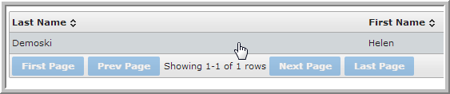

You can also right-click on the row to select from three options: **Consent** to audit patient consent history (i.e. “opt-in/out”); **Collaborate** for auditing patient record access; or **Add to My Census** to save the patient to your own list for later review.

